SENSITIVITY ANALYSIS FOR UPPER.EAST4 REGION – GHANA
INCLUDE EIR IN TRAINING AND FILTER ONE EIR VALUE FOR PREDICTION
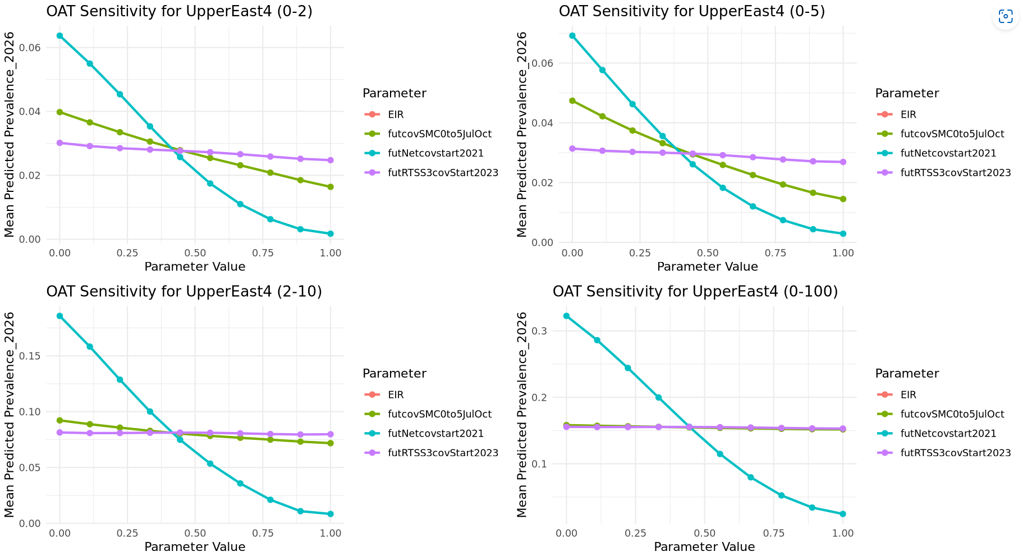

EIR AS A PREDICTOR IN BOTH TRAINING AND PREDICTION EIR NOT A PREDICTOR FOR BOTH TRAINING AND PREDICTION
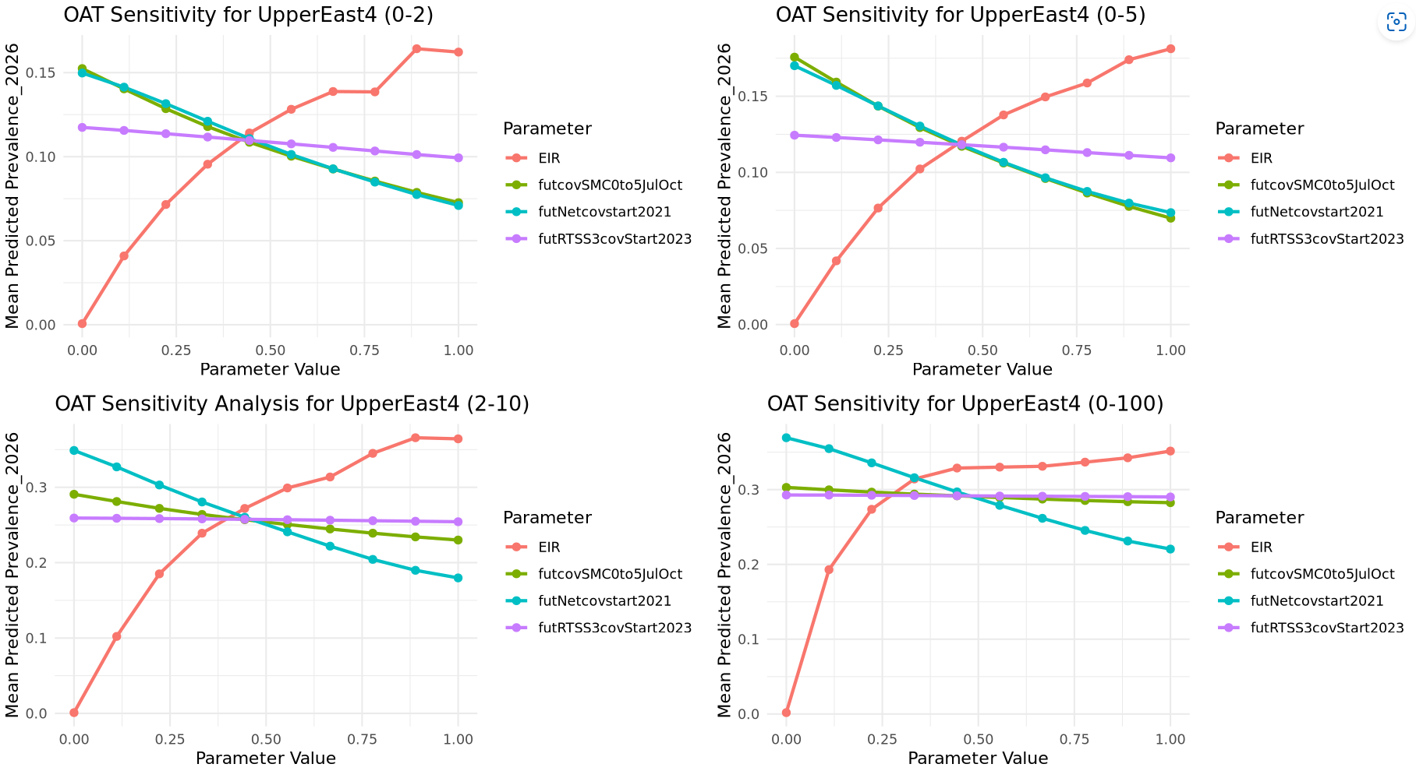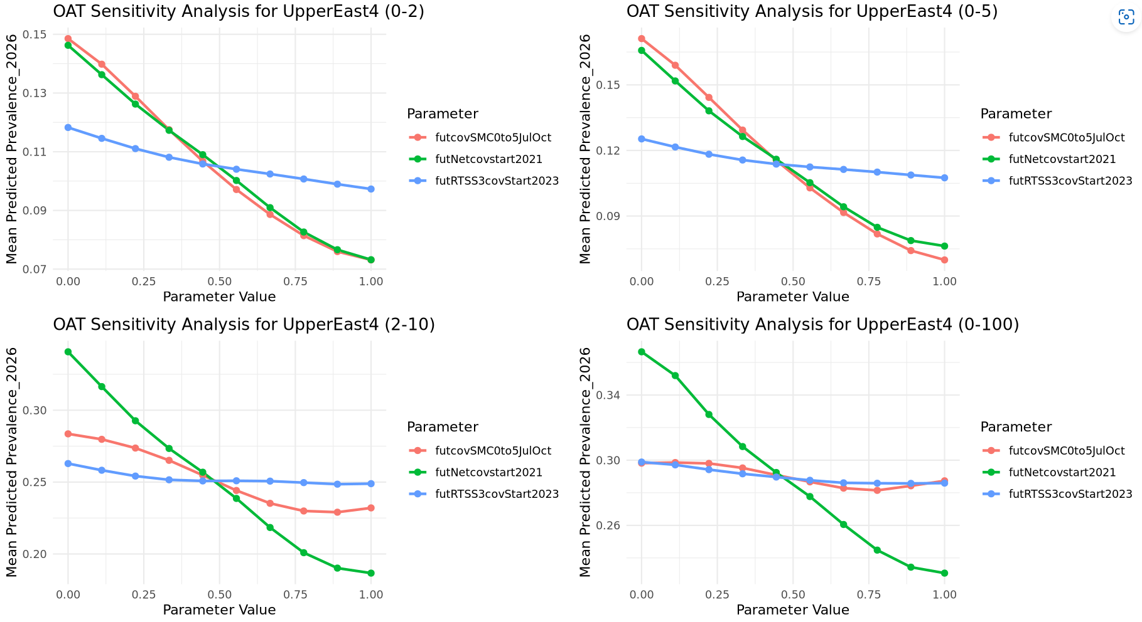

EIR AS A PREDICTOR IN BOTH TRAINING AND PREDICTION

This gives a quick and preliminary idea of which parameters have the most impact on the output. By identifying the parameters that have little to no effect on the output, you can narrow down the list of parameters to focus on for more in-depth analysis using Sobol. This reduces the computational cost of running a Sobol analysis on many unimportant parameters
- By first performing OAT, you can eliminate or deprioritize parameters that do not significantly impact the output, making the later Sobol analysis more targeted and efficient
- OAT provides a baseline understanding of the system’s behavior

SOBOL
- FULL EIR RANGE FOR TRAINING AND PREDICTION (LHS SAMPLING OF X1 AND X2 IN SOBOLSALT)
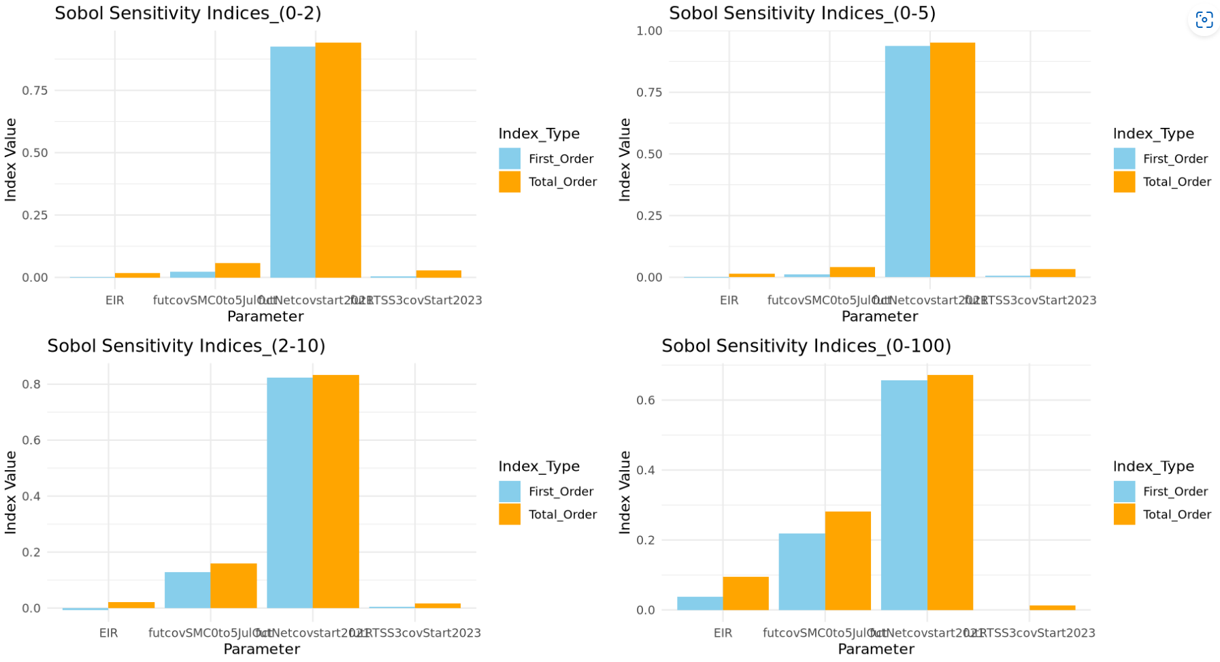
NB: Properties of Sobol sensitivity indices (for the interpretation of the results)
- STi is greater than Si, or equal to Si in the case that Xi is not involved in any interaction with other input factors.
- STi − Si is a measure of how much parameter Xi is involved in interactions with any other input parameter
- STi = 0 implies that Xi is noninfluential and can be fixed anywhere in its distribution without affecting the variance of the output
- The sum of all Si is equal to 1 for additive models and less than 1 for nonadditive models.
- The difference 1 − ∑Si is an indicator of the presence of interactions in the model.
- The sum of all STi s is always greater than 1. It is equal to 1 if the model is perfectly additive.

- FIRST ORDER AND INTERACTION EFFECTS PLOT
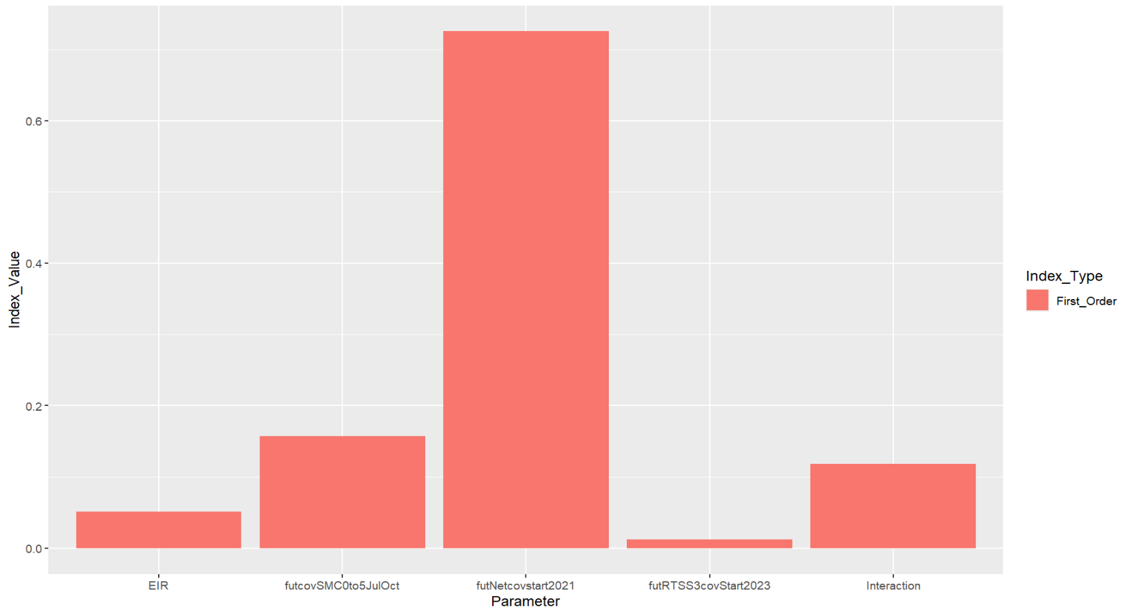
NB: Si indicates by how much one could reduce, on average, the output variance if Xi could be fixed.
The output variance (uncertainty in prevalenceRate) could be reduced by over 50%, on average, if futNetcov could be estimated.
ACTUAL VS PREDICTED WITH EIR AS A PREDICTOR
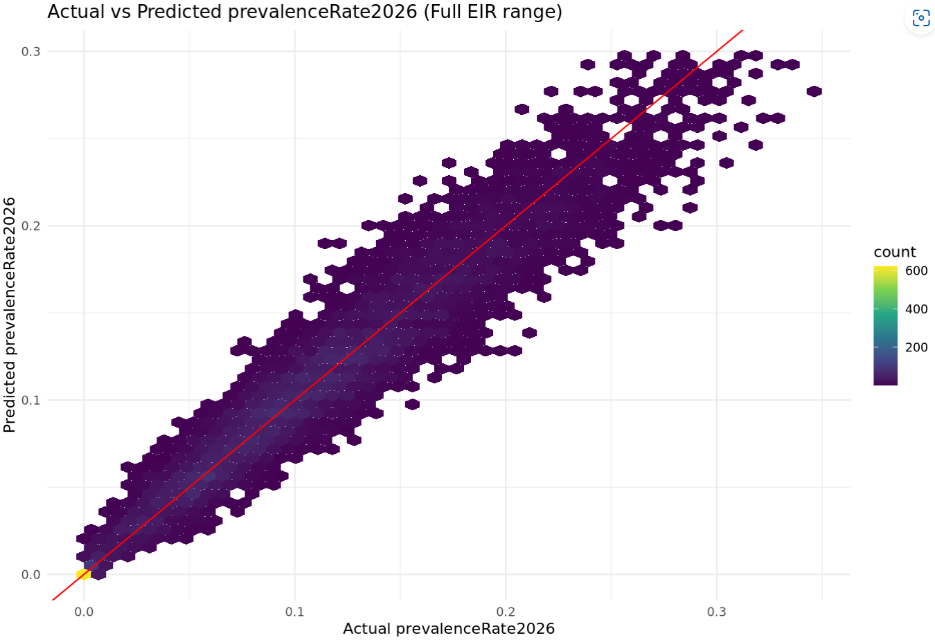

SOBOL INDICES (LHS SAMPLING OF PARAMS with GAUSSIAN EIR)
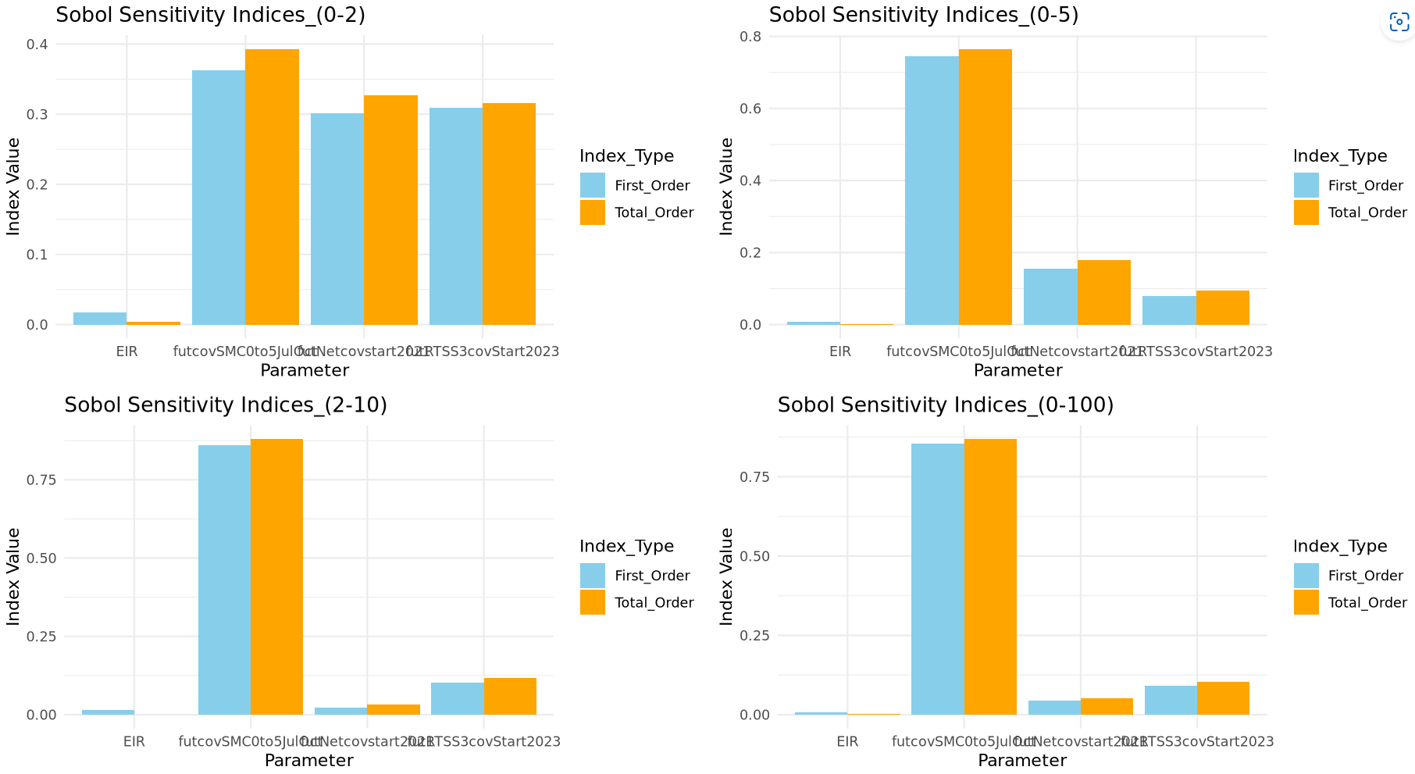

Upper.east4
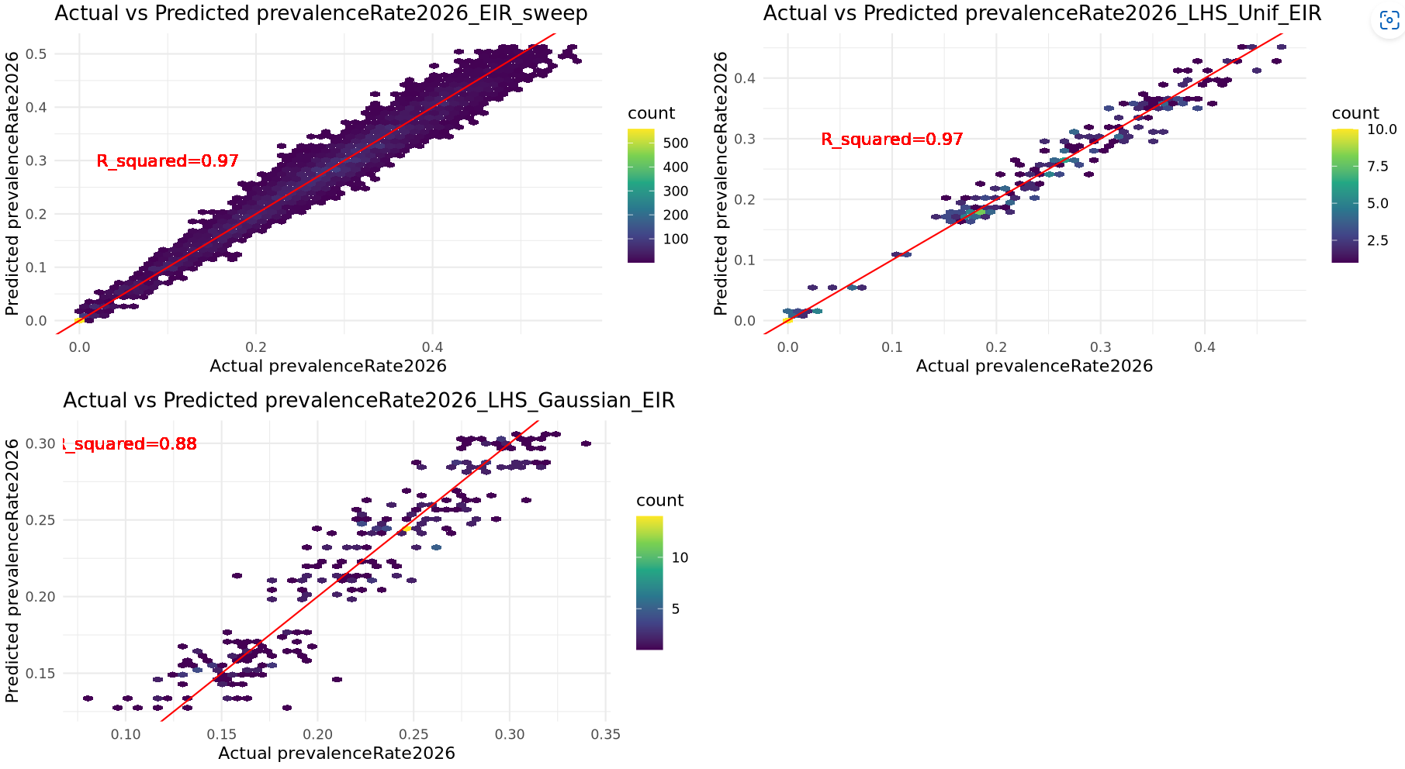

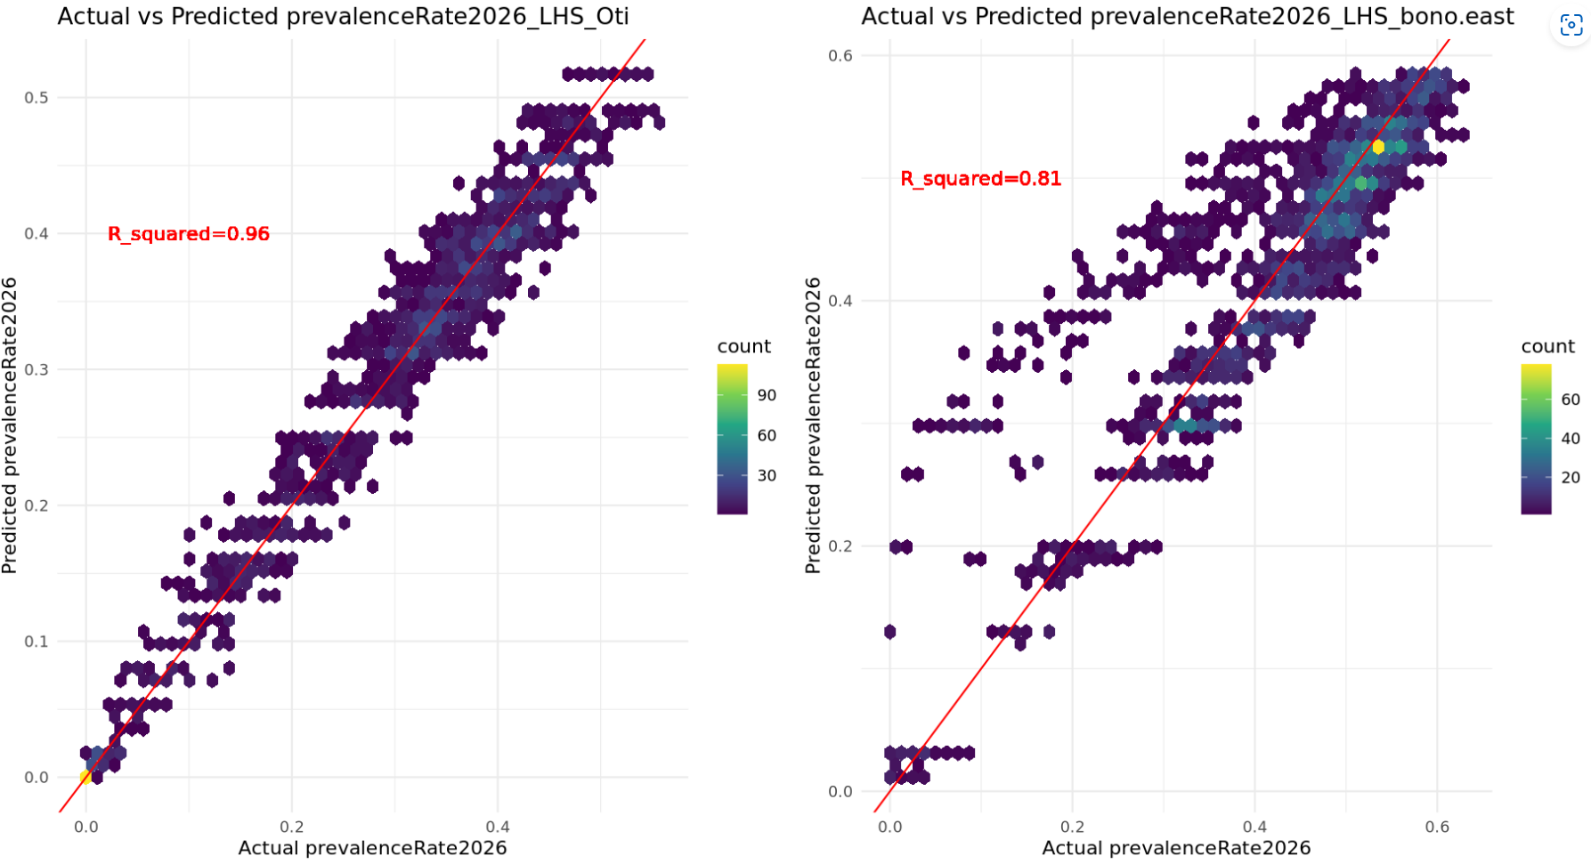

ZOOM INTO TH 0-2 PREV WINDOW (UE, BE and OTI) - REDO
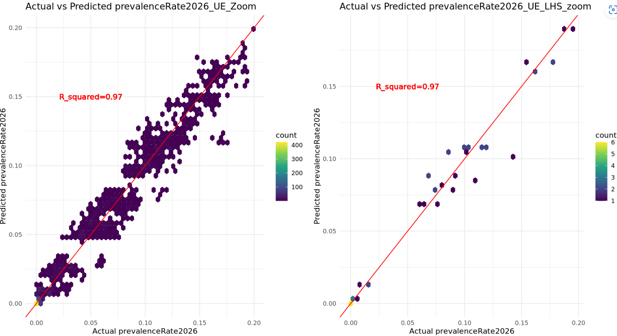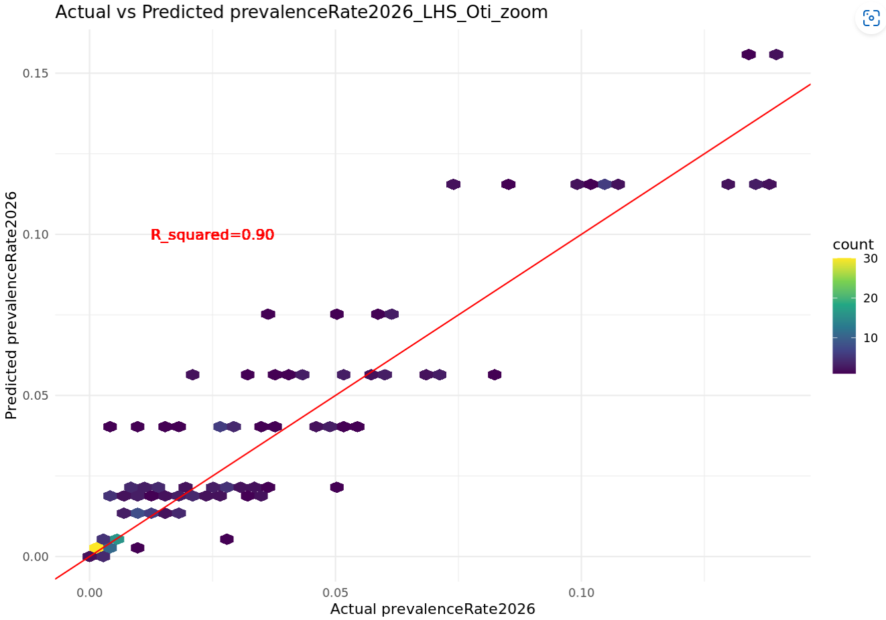

TABLE –
Y_COL = prevalenceRate_2026, AGE_GROUP = 2-10
SETTING | NUMBER OF SIMULATIONS REQUIRED (SWEEPS) / TRAIN DATA SIZE | NUMBER OF SIMULATIONS REQUIRED (LHS) / TRAIN DATA SIZE | R-SQUARED | NUMBER OF X_COLS | GP TRAINING TIME (mins)
UPPER.EAST4 | /50K | / | 0.97 | 5 | 11.9
OTI | 300000 | 2500 / 2500 | 0.96 | 5 | 1.9
BONO.EAST (no_LSM) | 212500 | 2000/2000 | 0.95 | 5 | 1.4

Train GP with the whole sim_data
